
RAMAIAH
Institute of Technology
USN | 1 | M | S

(Autonomous Institute, Affiliated to VTU)
(Approved by AICTE, New Delhi & Govt. of Karnataka) Accredited by NBA & NAAC with ‘A’ Grade

EXAMINATIONS SEPTEMBER /OCTOBER 2020
SUPPLEMENTARY SEMESTER / GRADE IMPROVEMENT/ RE –REGISTERED CANDIDATES
Program | : | B.E.: Electrical and Electronics Engineering | Semester | : | VII
Course Name | : | Generation, Economics and Reliability Aspects of Power Systems | Max. Marks | : | 100
Course Code | : | EEE20 | Duration | : | 3 Hrs

Instructions to the Candidates:
- Answer one full question from each unit.

 |  | UNIT- I
1. | a) | Explain the advantages and disadvantages of diesel plants. | CO1 | (06)
 | b) | Explain the working of nuclear power plant with a diagram. | CO1 | (08)
 | c) | Classify the hydro plants based on Quantity of water available and heads. | CO1 | (06)
2 | a) | Discuss the heat balance sheet and degradation in the performance of units in thermal power plants. | CO1 | (07)
 | b) | Discuss the waste disposal mechanism in the case of nuclear power generation. | CO1 | (07)
 | c) | List out the different mechanism for restructuring power sector for environmental benefits. | CO1 | (06)
 |  | UNIT- II
3. | a) | Define plant utilization factor and diversity factor. | CO2 | (04)
 | b) | A steam station is erected at cost of Rs 2x10⁸ salvage value is 15% of initial cost Life is 25 years, Sinking fund interest is 8%. Find the depreciated value of the equipment after 10 years with i)straight line method ii) Diminishing value method iii) Sinking fund method. | CO2 | (08)
 | c) | A generating station has a maximum demand of 75MW and load factor is 0.4.Generating cost is Rs60 per annum per kW of maximum demand plus 4 paise per kWh transmitted. Annual capital charges of transmission system are 20 lakhs and distribution system are 15 lakhs. Diversity factor of transmission and distribution system is 1.2 and 1.25.Transmission and distribution system are 90% and 85 % efficient. Find yearly cost per kW demand, cost at substation and consumer premises. Costs given are inclusive of interest and depreciation. | CO2 | (08)
4. | a) | An Electrical Supply company has following annual expenses.  No of units generated/ year is 430x10⁶ KWh Consumer has an aggregate demand of 80MW, losses in transmission and distribution is 10%. Determine the two part tariff | CO2 | (07)
   | Total cost in Rs | Fixed cost in %
  Generation | Rs 80x10⁴ | 80%
  Transmission | Rs 25x 10⁴ | 90%
  Distribution | Rs 20x10⁵ | 95%
  Fuel | Rs 30X10⁵ | 15%
  Repair | Rs 3.5x10⁵ | 50%
 | b) | A 25 HP Motor is burnt beyond the repair Two alternatives are available  Energy cost is 10 paise per kWh, life of the motor is 20 Years. Find the economical alternative. | CO2 | (08)
   | Motor A | Motor B
  Capital cost | Rs 5000 | Rs 4000
  Efficiency | ¼ of the Year efficiency is 0.90 with full load  ¾ of the Year efficiency is 0.85 with half load | ¼ of the Year efficiency is 0.85 with full load  ¾ of the Year efficiency is 0.82 with half load
  Interest and Depreciation | 5% | 5%
  Salvage value | 5% of the capital cost | 5% of the capital cost
  Maintenance cost | Rs 400 | Rs 500
 | c) | Discuss the evolution of energy market. | CO2 | (05)
 |  | UNIT- III
5. | a) | Differentiate between adequacy and Security aspects of reliability. | CO3 | (05)
 | b) | List the factors which decreases the reliability of the power systems. | CO3 | (05)
 | c) | A small generating plant is designed to satisfy a constant 10 MW load  Three alternatives are being considered i)1x 10 Mw unit ii)2x10 MW unit iii)3x 5Mw unit with Forced outage rate of 0.02.  Prepare the capacity outrage probability table for each of three alternatives. | CO3 | (07)
 | d) | Expand the following abbreviation:  i)LOEE ii)LOLE iii)EIR. | CO3 | (03)
6. | a) | List the properties of markov chain probabilistic techniques and its applications. | CO3 | (06)
 | b) | Differentiate between Three state and two state model. | CO3 | (04)
 | c) | Calculate the Energy Index of Reliability for the following Load Duration Curve with system having three identical units of having capacity of 100 MW with FOR 0.03.  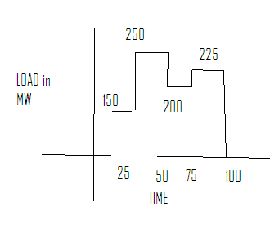 | CO3 | (10)
 |  | UNIT- IV
7. | a) | What is load curtailment technique and why it is necessary? | CO4 | (06)
 | b) | What is outage in power system and how it can be classified? | CO4 | (06)
 | c) | Find the Energy Index of Reliability for the following Load duration curve with system having two units with capacities of 25Mw & 50 Mw with FOR of 0.02 and 0.03 respectively.  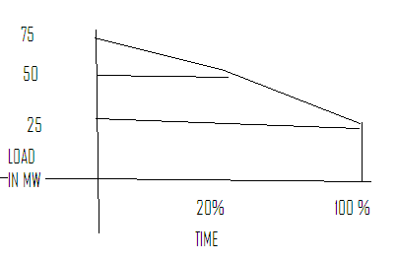 | CO4 | (08)
8. | a) | What is reserve and discuss the factors affecting it? | CO4 | (08)
 | b) | Differentiate between ENEL and U of S approach. | CO4 | (06)
 | c) | Explain contingency enumeration approach with flowchart. | CO4 | (06)
 |  | UNIT- V
9. | a) | With a flowchart explain contingency enumeration approach. | CO5 | (06)
 | b) | Derive the approximate expression for reliability indices evaluation for radial distribution system. | CO5 | (06)
 | c) | Find SAIFI, CAIDI, SAIDI and ASAI for the following set of customer data. | CO5 | (08)
  Line | Failure rate | Repair rate | No of customers | Avg. load demand
  A | 0.20 | 6.00 | 200 | 1000
  B | 0.10 | 5.00 | 150 | 700
  C | 0.15 | 8.00 | 100 | 400
10. | a) | What is interruption energy assessment rate? What factors contribute to its variation? | CO5 | (06)
 | b) | Explain how the interruption cost of residential customer varies with different factors. | CO5 | (06)
 | c) | Determine the system failure rate, unavailability and interruption duration for the data given in the table at different load point (LP) for a radial distribution system shown in Fig.10(c).  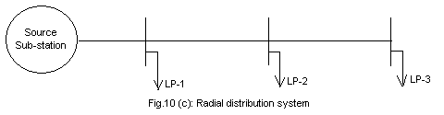 | CO5 | (08)
  Load point (LP) | Failure rate | Repair rate
  LP-1 | 0.1 | 5.0
  LP-2 | 0.2 | 8.0
  LP-3 | 0.3 | 7.0

****************

